Table of Contents

PM Docs Chapter 2 1

Charter 2

Objectives 2

Scope 2

Stakeholder analysis 2

Openproject Activities 2

Budgets 2

Roadmap 3

Work Packages 3

Backlogs 4

AY 2025-2026 T1 Sprint 01 Board 4

Gantt Chart 5

Design Thinking output (5 Stages): 5

Dataflow Diagrams 6

Use case Documentation 6

Activity diagrams with swim-lanes 6

Entity Relationship Diagram 6

Technology Stack 7

Frontend Framework 7

Backend Framework 7

Frontend/ Backend communication 7

Github APC-SoCIT project repository URL Link 7

Openproject Team Site URL Link 8

Cloud hosted site URL Link 8

# **PM Docs Chapter 2**

## **Charter**

<https://asiapacificcollege.sharepoint.com/:w:/r/sites/MSYADD1MI231T1AY2025-2026/_layouts/15/Doc.aspx?sourcedoc=%7BF8E9E828-A5AF-4A0B-B6BF-E1C5BA7B49B2%7D&file=ByteMe%20-%20CHARTER.docx&action=default&mobileredirect=true>

## **Objectives**

<https://asiapacificcollege.sharepoint.com/:w:/r/sites/MSYADD1MI231T1AY2025-2026/_layouts/15/Doc.aspx?sourcedoc=%7BAE3FEC69-501E-4FE2-8C02-05F9811B900D%7D&file=ByteMe%20-%20OBJECTIVES.docx&action=default&mobileredirect=true>

## **Scope**

<https://asiapacificcollege.sharepoint.com/:w:/r/sites/MSYADD1MI231T1AY2025-2026/_layouts/15/Doc.aspx?sourcedoc=%7B475E402C-5561-4A84-B8D5-C9D2A888B807%7D&file=ByteMe%20-%20SCOPE.docx&action=default&mobileredirect=true>

## **Stakeholder analysis**

<https://asiapacificcollege.sharepoint.com/:x:/r/sites/MSYADD1MI231T1AY2025-2026/_layouts/15/Doc.aspx?sourcedoc=%7BCEBB048A-C2C6-4E18-936A-14DFF95DE4F9%7D&file=ByteMe%20-%20STAKEHOLDER%20ANALYSIS.xlsx&action=default&mobileredirect=true>

# **Openproject Activities**

<https://openproject2025.apc.edu.ph/projects/apc-2025-2026-t1-mi231-g06-byteme-solennia/>

## **Budgets**

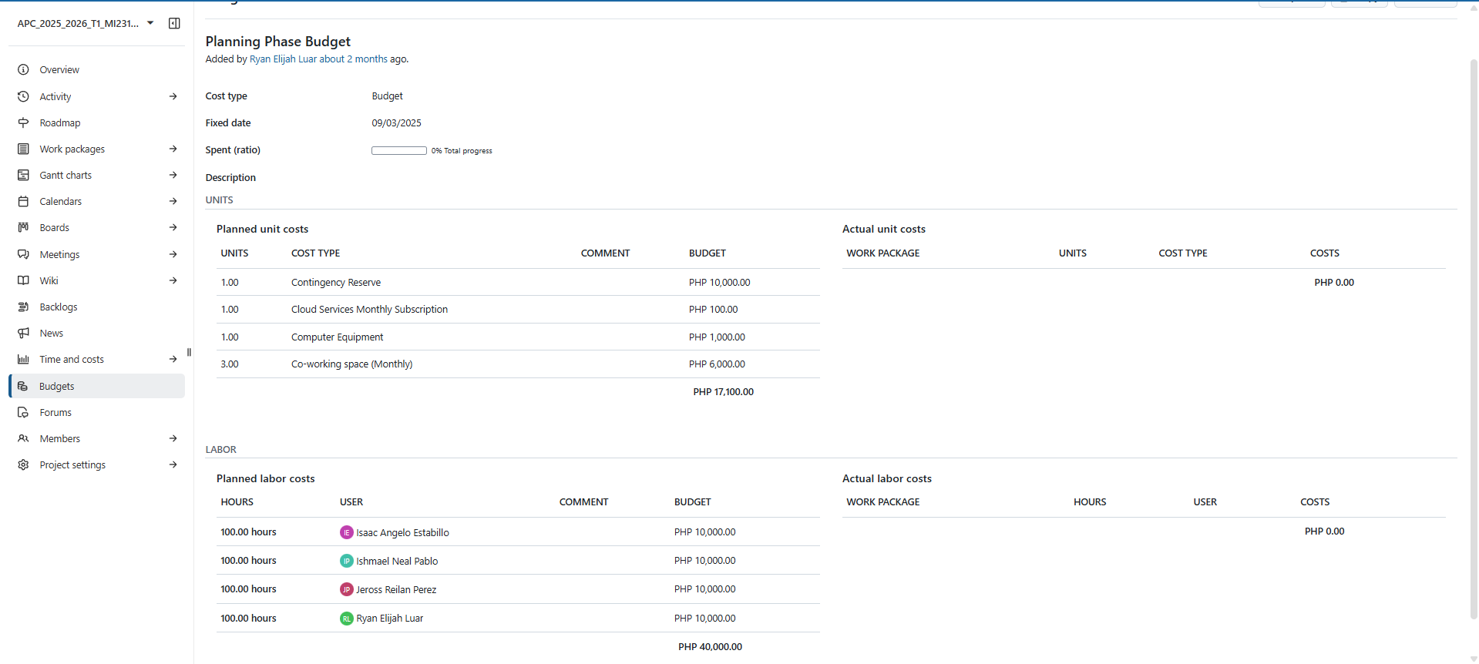

## **Roadmap**

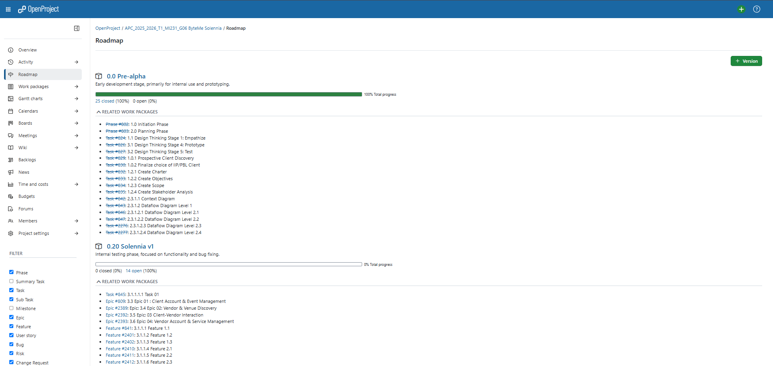

## **Work Packages**

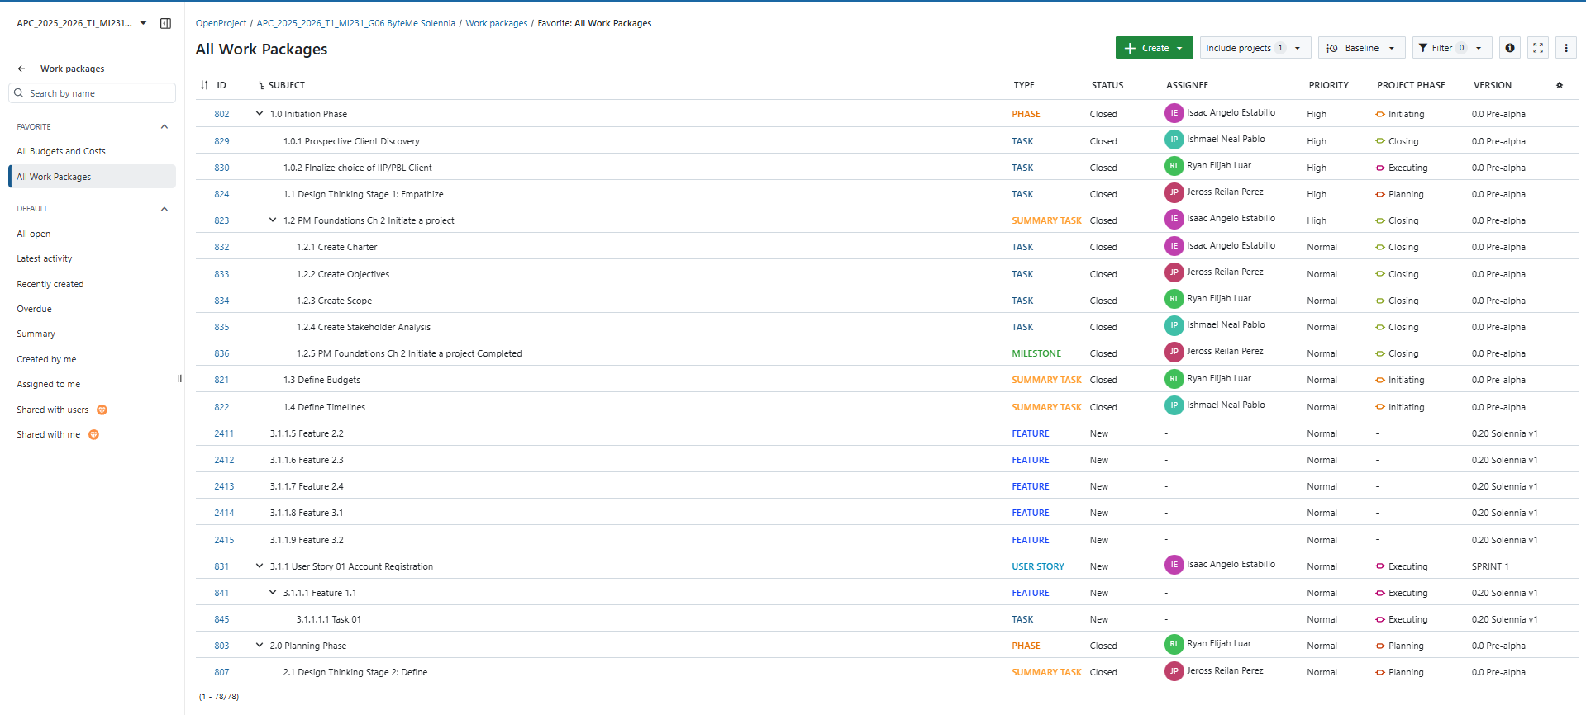

## **Backlogs**

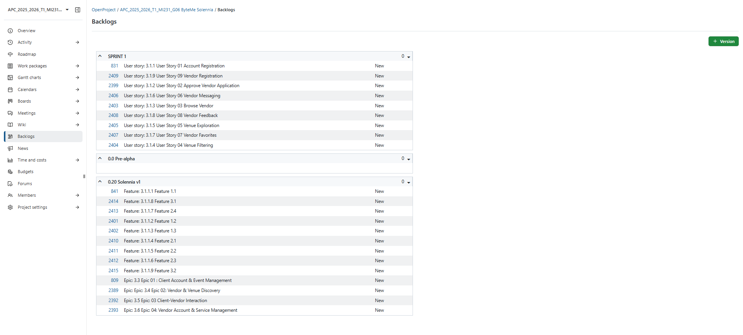

## **AY 2025-2026 T1 Sprint 01 Board**

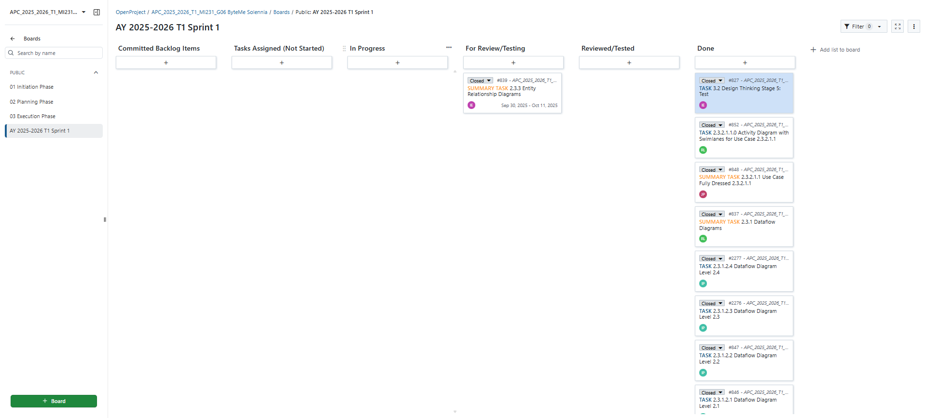

## **Gantt Chart**

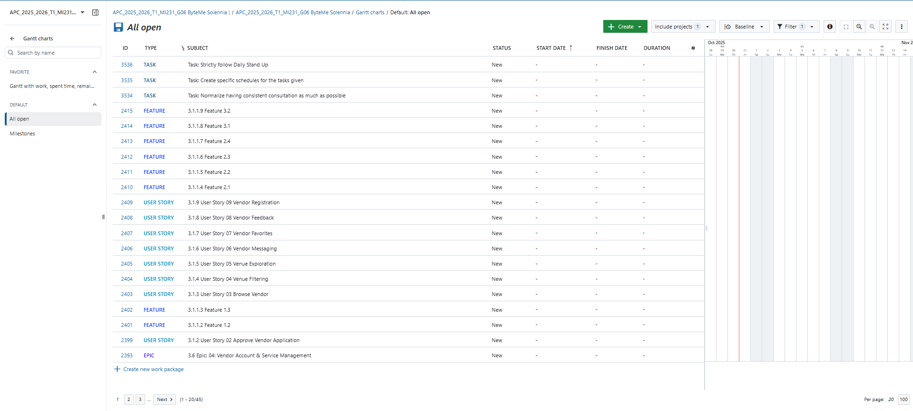

# **Design Thinking output (5 Stages):**

<https://asiapacificcollege.sharepoint.com/:w:/r/sites/MSYADD1MI231T1AY2025-2026/_layouts/15/Doc.aspx?sourcedoc=%7B64D888C1-D21E-411B-AFEC-589A566EE3D1%7D&file=ByteMe%20-%20Design%20Thinking%20Activities.docx&action=default&mobileredirect=true>

**Dataflow Diagrams**

<https://www.canva.com/design/DAG1pjuFjig/PqHMawoTk-0UcPd0DsZHVw/edit?utm_content=DAG1pjuFjig&utm_campaign=designshare&utm_medium=link2&utm_source=sharebutton>

# **Use case Documentation**

<https://asiapacificcollege-my.sharepoint.com/:w:/g/personal/jrperez2_student_apc_edu_ph/EUC9VX9qCXJGjkwtQCOlzO8BZf--NGp7-WgrtmG1bJq_tg?e=TP3hVt>

## **Activity diagrams with swim-lanes**

<https://drive.google.com/file/d/1ugL7cimF7AsrCbG97bqUHCIP2UVC_8pX/view?usp=sharing>

# **Entity Relationship Diagram**

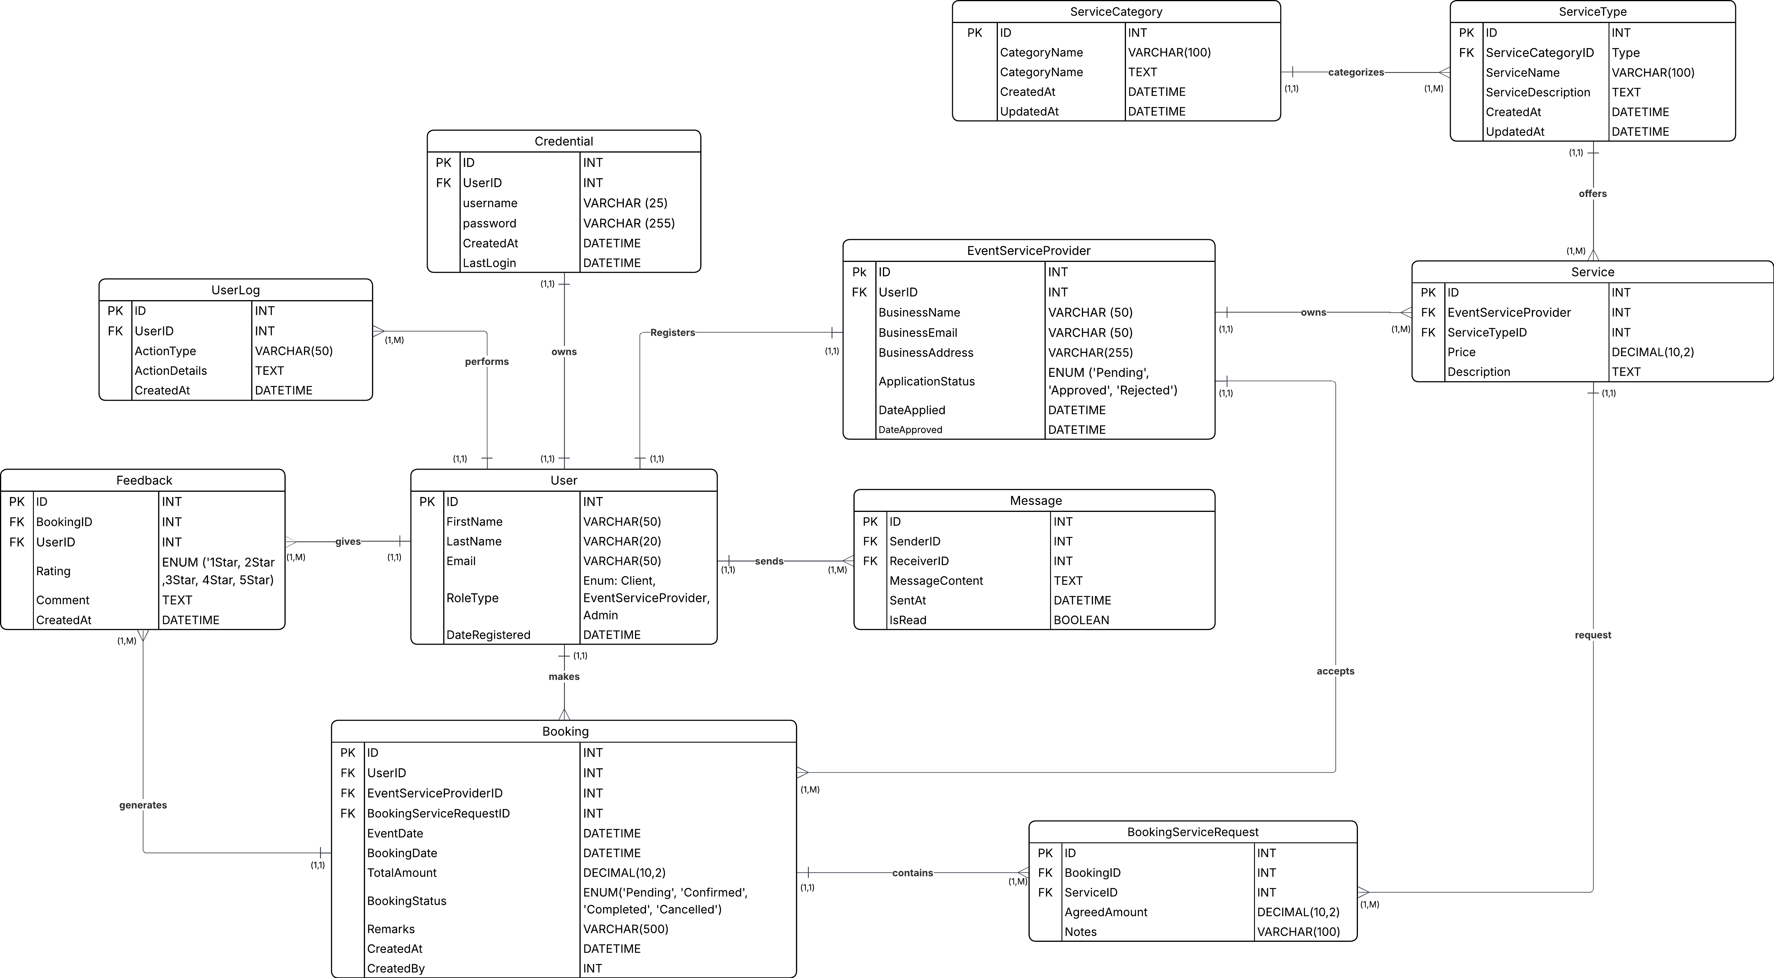

# **Technology Stack**

## **Frontend Framework**

Vite JS

## **Backend Framework**

PHP Slim 4

## **Frontend/ Backend communication**

Rest API

# **Github APC-SoCIT project repository URL Link**

<https://github.com/APC-SoCIT/APC_2025_2026_T1_MI231_G06-Solennia>

# **Openproject Team Site URL Link**

<https://openproject2025.apc.edu.ph/projects/apc-2025-2026-t1-mi231-g06-byteme-solennia>

# **Cloud hosted site URL Link**

<https://solennia.vercel.app/>